
Lesson 5 Teacher's Key
Unity
INSTRUCTOR ONLY - do not distribute to students

Level 1 - Complete Worked Solution
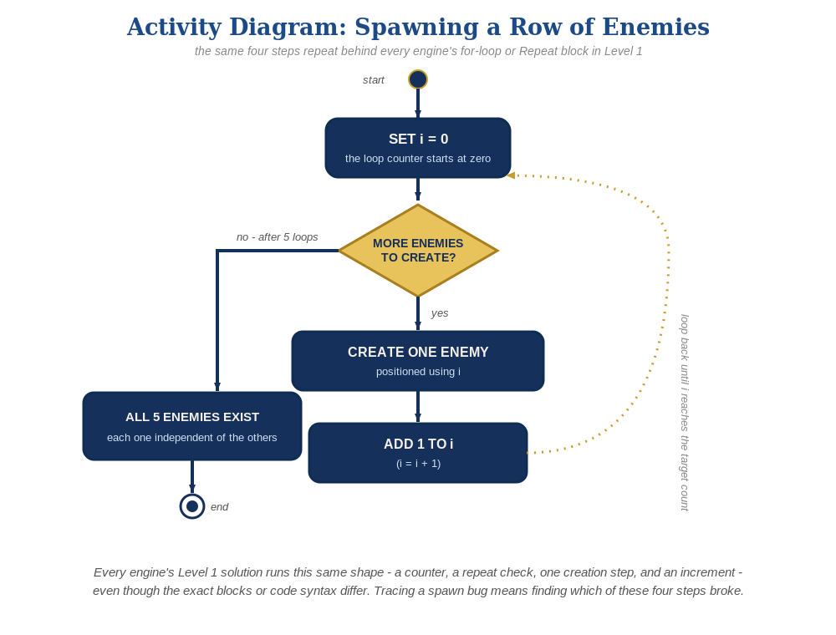
The spawn loop, in general - the same counter, repeat check, creation step, and increment behind Level 1 in every engine, whatever the exact blocks or syntax look like.
A new EnemySpawner.cs on a new empty GameObject - Enemy.cs and Bullet.cs need zero changes from Lesson 4:
// EnemySpawner.cs:
public GameObject enemyPrefab;
public int enemyCount = 5;
void Start() {
for (int enemyIndex = 0; enemyIndex < enemyCount; enemyIndex++) {
Vector3 pos = new Vector3(-4f + enemyIndex * 2f, 4f, 0f);
Instantiate(enemyPrefab, pos, Quaternion.identity);
}
}

Level 2 - Complete Worked Solution
Bullet.cs's OnTriggerEnter2D and Enemy.cs's own Start() are fully self-contained per instance, so every prefab copy the loop creates behaves independently and correctly with no extra code needed for Level 2.

Level 3 - All Worked Solutions
Every stretch-goal idea from the handout, fully worked - not just one. Useful for validating each idea actually works before class, and as a ready reference no matter which one a student ends up picking.

Sound: already works
AudioSource.PlayClipAtPoint() in Bullet.cs runs independently for every enemy that gets hit - no changes needed.

Visual: striped row
Set the SpriteRenderer color right after Instantiate() in the spawner, using the loop index. new Color(0.8f, 0.1f, 0.2f) is a deep crimson red and new Color(0.95f, 0.4f, 0.5f) is a lighter dusty rose/pink - alternating them by enemyIndex % 2 makes every other enemy a visibly different shade of red, not a blended new color. Written as a plain if/else rather than a one-line ternary - readable at a glance for a student who hasn't met the ternary operator yet (see this lesson's Book Notes entry: that's deliberately saved for a later, more advanced project):
for (int enemyIndex = 0; enemyIndex < enemyCount; enemyIndex++) {
Vector3 pos = new Vector3(-4f + enemyIndex * 2f, 4f, 0f);
GameObject newEnemy = Instantiate(enemyPrefab, pos, Quaternion.identity);
if (enemyIndex % 2 == 0) {
newEnemy.GetComponent<SpriteRenderer>().color = new Color(0.8f, 0.1f, 0.2f);
} else {
newEnemy.GetComponent<SpriteRenderer>().color = new Color(0.95f, 0.4f, 0.5f);
}
}

Structure: spawner vs. behavior stay separate
EnemySpawner.cs only ever creates and positions enemies - collision-response and hit-sound logic stay entirely inside Enemy.cs and Bullet.cs.

Complete Level 3 solution (all 3 goals combined)
The spawner loop with the visual idea added - sound needs no changes since it already lives on Bullet.cs:
public GameObject enemyPrefab;
public int enemyCount = 5;
void Start() {
for (int enemyIndex = 0; enemyIndex < enemyCount; enemyIndex++) {
Vector3 pos = new Vector3(-4f + enemyIndex * 2f, 4f, 0f);
GameObject newEnemy = Instantiate(enemyPrefab, pos, Quaternion.identity);
if (enemyIndex % 2 == 0) {
newEnemy.GetComponent<SpriteRenderer>().color = new Color(0.8f, 0.1f, 0.2f);
} else {
newEnemy.GetComponent<SpriteRenderer>().color = new Color(0.95f, 0.4f, 0.5f);
}
}
}

Alternate Path Notes: Visual Scripting
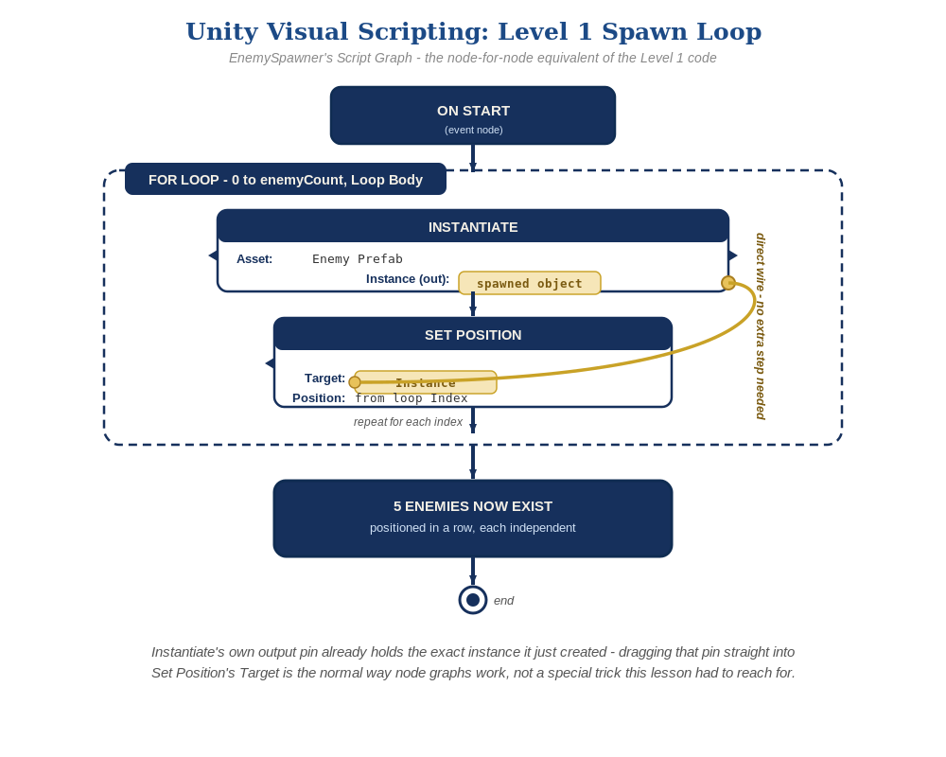
The Script Graph, node by node - Instantiate's own output pin plugs straight into Set Position's Target, no extra step needed.
A For Loop node (0 to enemyCount) feeding Instantiate + Set Position nodes is the graph equivalent of the C# for loop.
The Level 3 goals map onto nodes the same way: a "Set Member" node on the newly spawned instance's Sprite Renderer color for the visual idea - Sound needs no changes either way, since it lives on the Bullet's own graph, not the spawner's.
- Keeping the same Structure principle (a spawner only spawns; behavior lives on the spawned object) whether a student is in C# or graphs reinforces that it's a design idea, not a syntax rule.

